**Advanced Software Engineering (CS 5551)**

**Project Group -3**

**Third Increment**

**Services for Students with Disabilities (SSD)**

**Suresh Yarra, Prudhvi Raj, Shravan Kumar, Anil Kanth**

# **1** **Existing or New Services/API**

All of the services we considered were the ones from what we have from second increment

and also,we used some popular API’s to full fill our requirements like Google Maps, Google Places, Speech Recognition and youcanbookme for appointments.

**URL1:**

<http://kcscecs551.kc.umkc.edu/aspnet_client/Group3/WebApplication1/WebApplication1/WebService1.asmx>

**URL2:**<http://kcscecs551.kc.umkc.edu/aspnet_client/Group3/SSDRestService/SSDRestService/Service1.svc/insertInfo>

**URL 3:**

<http://kcscecs551.kc.umkc.edu/aspnet_client/Group3/SSDRestService/SSDRestService/addUsers.svc/insertInfo>

**URL 4:**

<http://kcscecs551.kc.umkc.edu/aspnet_client/Group3/SSDRestService/SSDRestService/Students.svc/insertInfo>

**URL 5:**

<http://kc-sce-cs551.kc.umkc.edu/aspnet_client/Group3/C2/ASEService/ASEService/Service1.svc/get/suresh>

# 

# **2** **Design of Services**

Services we considered are student registration, Student login, adding goals and tasks. We also used services that are being offered by YouCanBookMe, where student books an appointment and data of appointment will be stored in our database.

## 

## 2.1 User Stories /Use Case (Using ScrumDo)

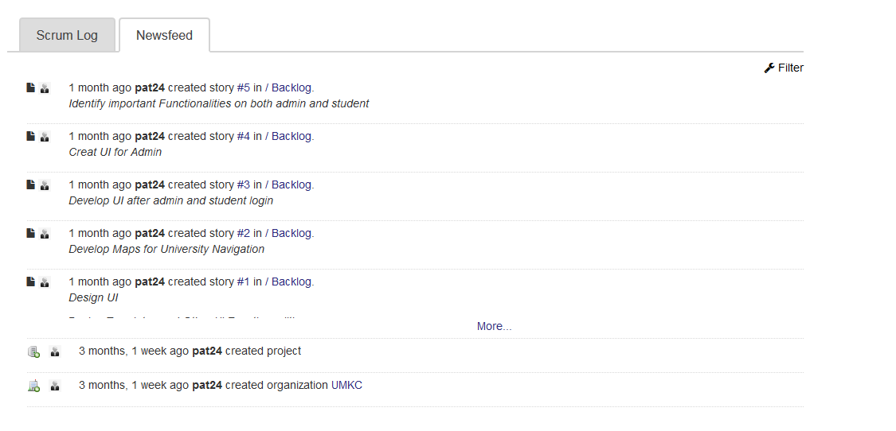

* We created user stories and assigned tasks for individual team members and they are as follows
* Identify template for Home page that fits the functionality keeping the design idea.
* Create Student, Admin and user login page with functionality providing student with registration form
* Design admin Dashboard panel with twitter bootstrap and jquery where admin will have monitoring functionality in a high level
* UI for Admin Side bar with options like make an Annoncment, View Student requests, view student profiles and also adding a user
* Design student home page with side bar options such as, Dashboard progress, view announcments, Add Goals, Core Values, Tasks and Scheduling appointment
* Desing Contact us page with basic contact info and map showing the direction to the location of KCBANCS office
* Design About page with some information that is in static content.
* Design page for parking that guides student to the nearest parking spot around umkc
* Design Entry point page where students will be able to see nearest accessible entry point in the campus
* Design place page where student can find nearest recreational facilities, atm, bank e.t.c..

## 

## 

## 2.2 WSDL: Service description

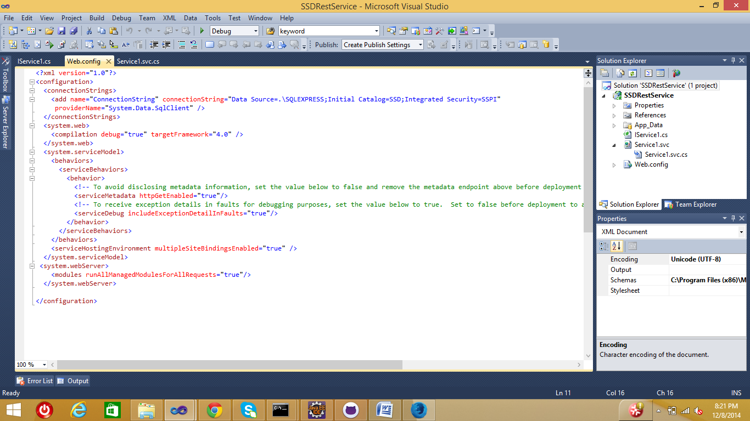

The above image is the example of one of our wsdl.

## 

## 2.3 Sequence diagram (using Visio)

## 

## 

## 

## 

## 

## 

## 

## 

## 2.4 Class diagram (using Visio)

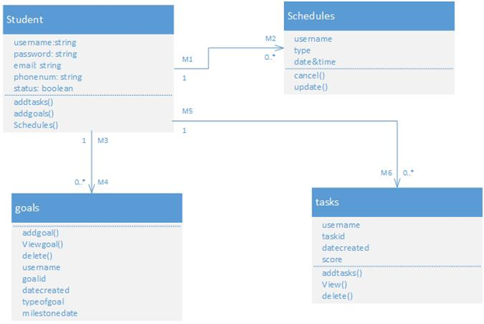

**2.5 System Architecture**

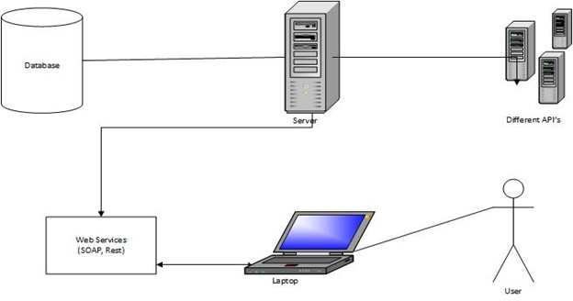

## 

## 2.7 Design of Unit test cases

We tested the services and done unit testing for some of the services we implemented in this project and they were working very perfectly.

Screenshot

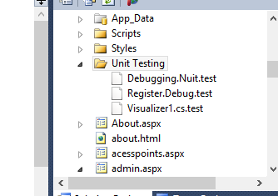

# 

# **3** **Implementation**

## 3.1 Implementation of Services

All the services we considered for this project are implemented successfully and were working pretty well

## 3.2 Implementation of User Interface

User Interface was developed using Jquery, Twitter Bootstrap and css. We focused on making the design more crisp and attractive. Screen shots will give us understanding that will be covered in following sections.

# **5** **Deployment**

## **5.1 Scrumdo URL**

<http://www.scrumdo.com/projects/project/cs5551fall14/summary>

## **5.2 GITHUB URL**

<https://github.com/yarrasuresh9999/SSD-ASE-Project-CS5551/>

**5.3 Screenshots**

Home Page

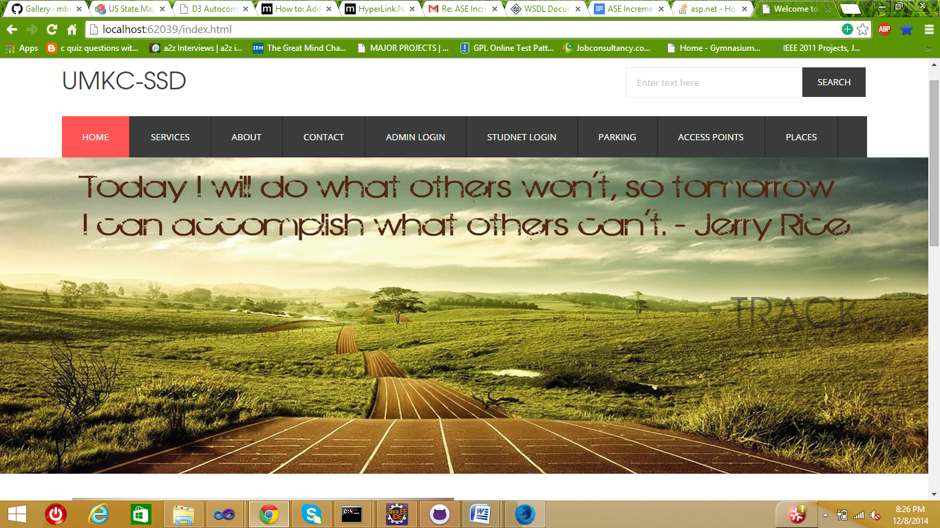

Services

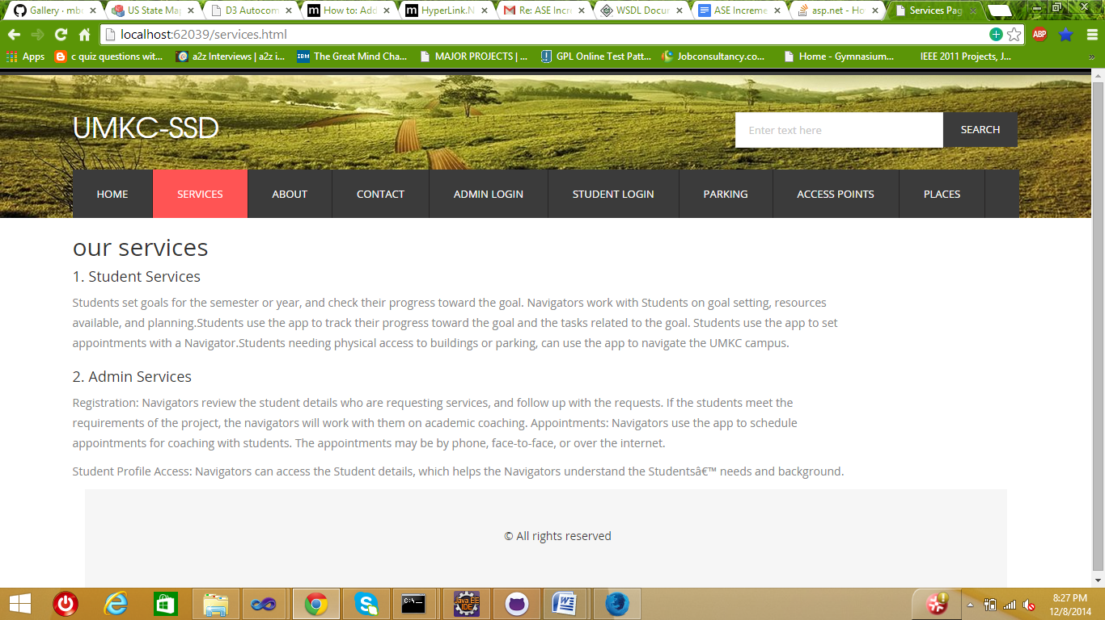

About Page

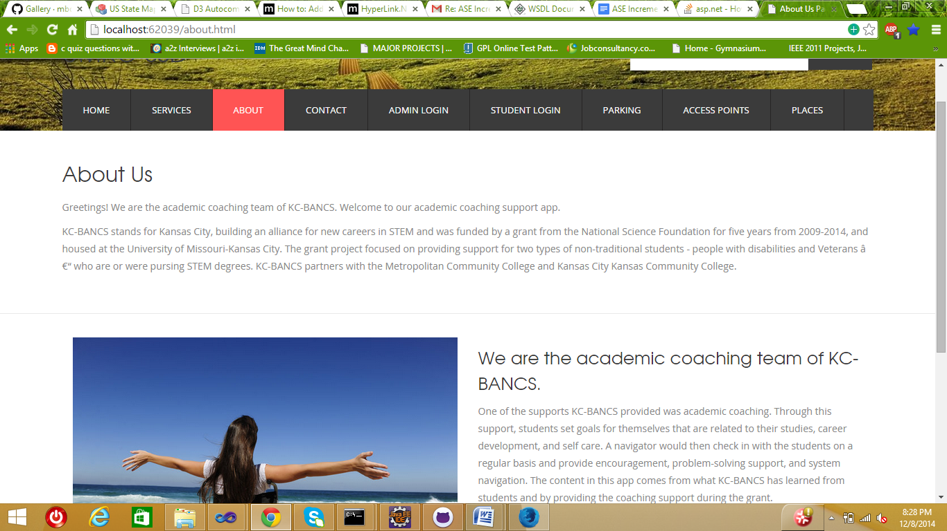

Contact page

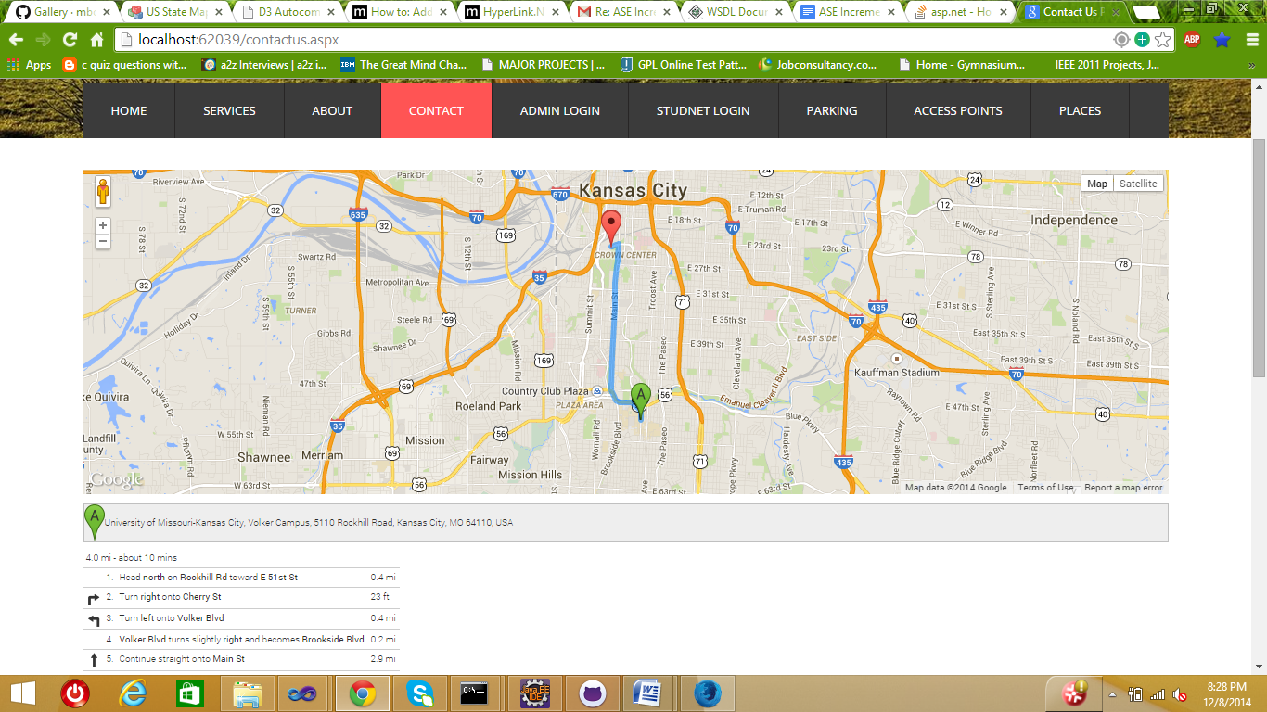

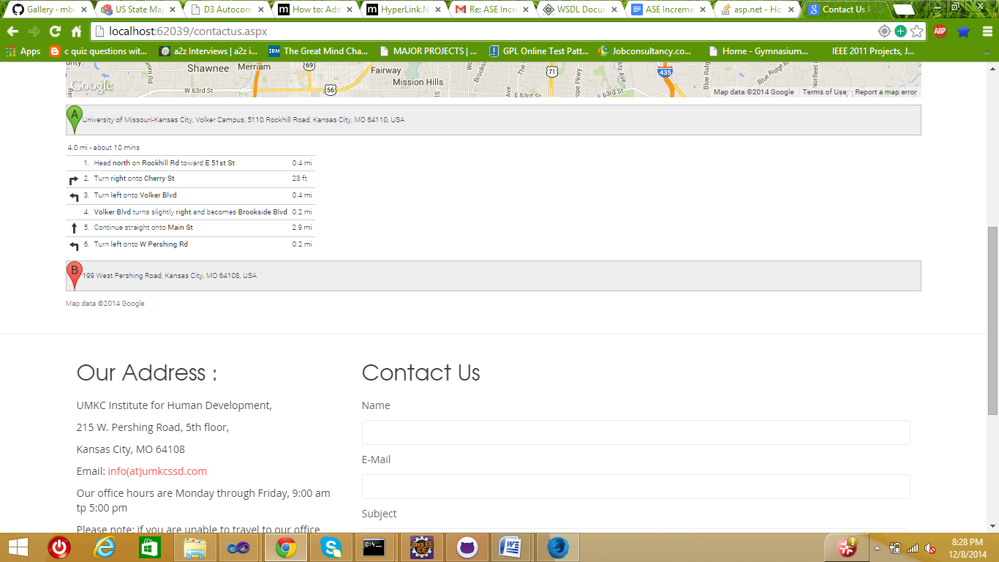

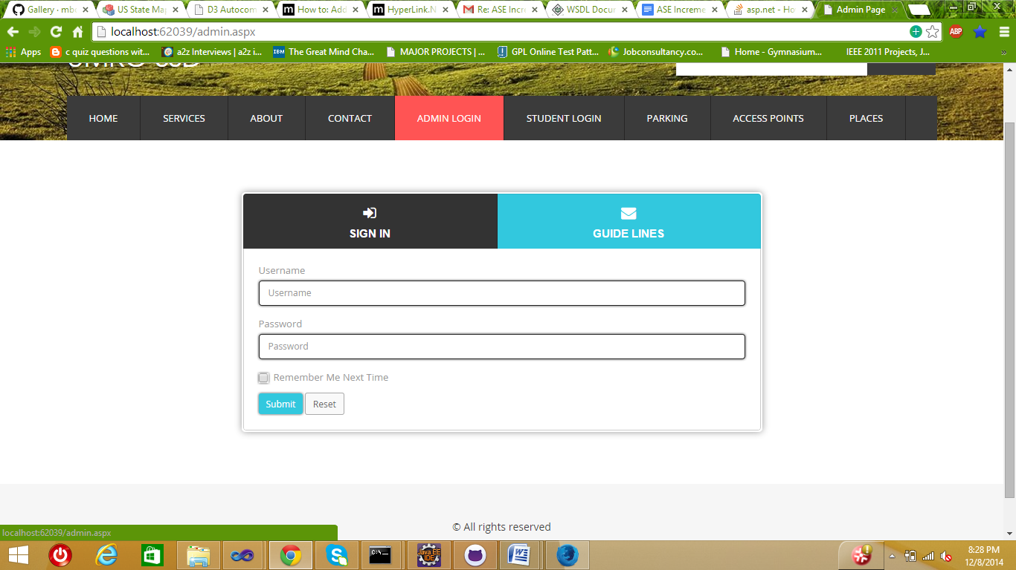

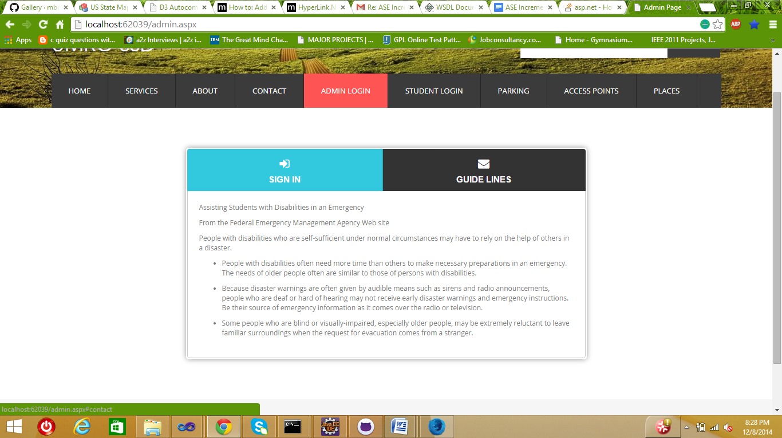

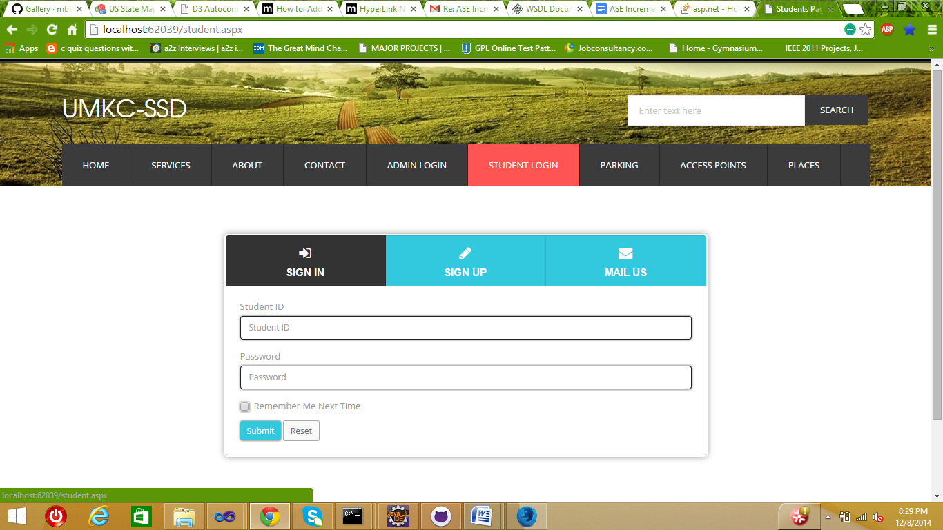

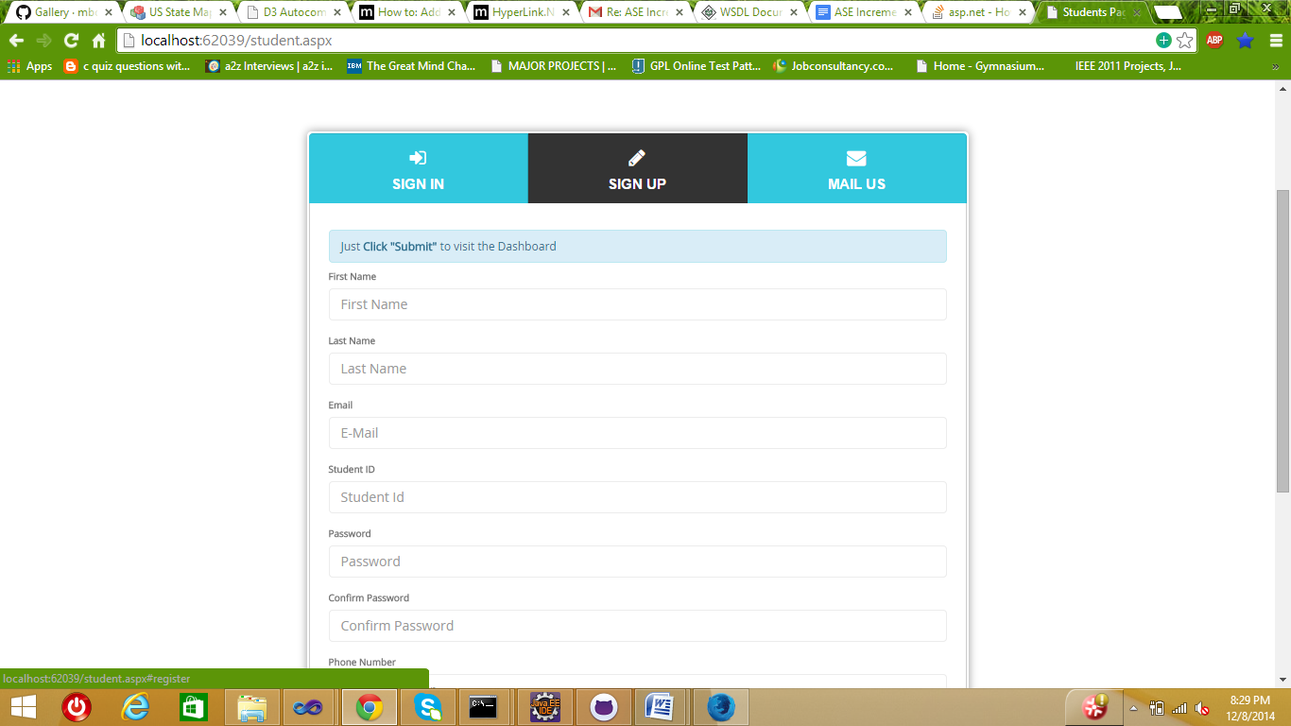

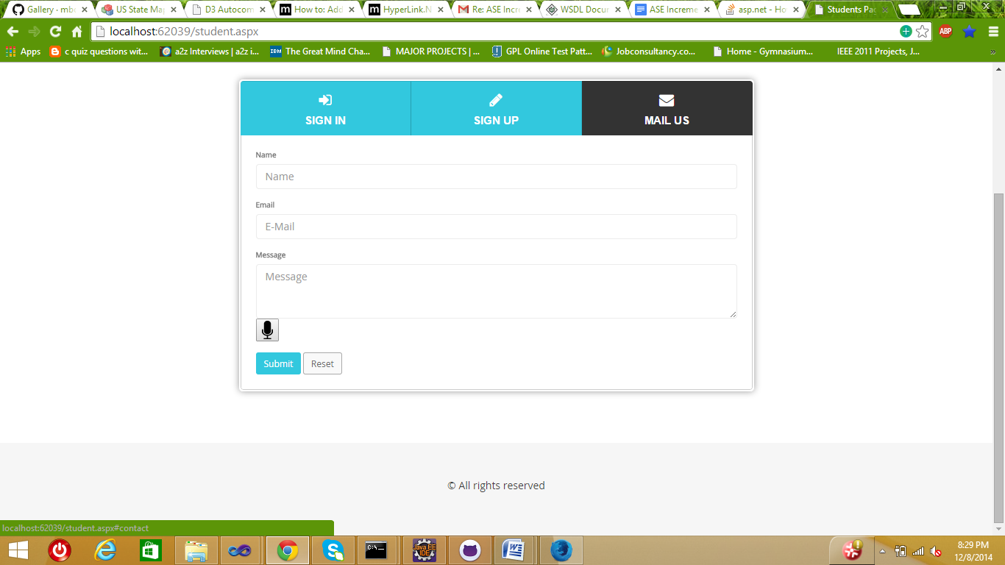

Parking

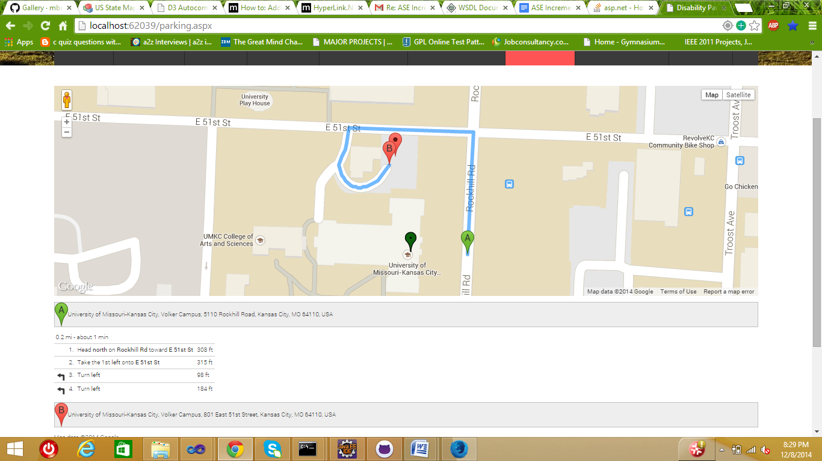

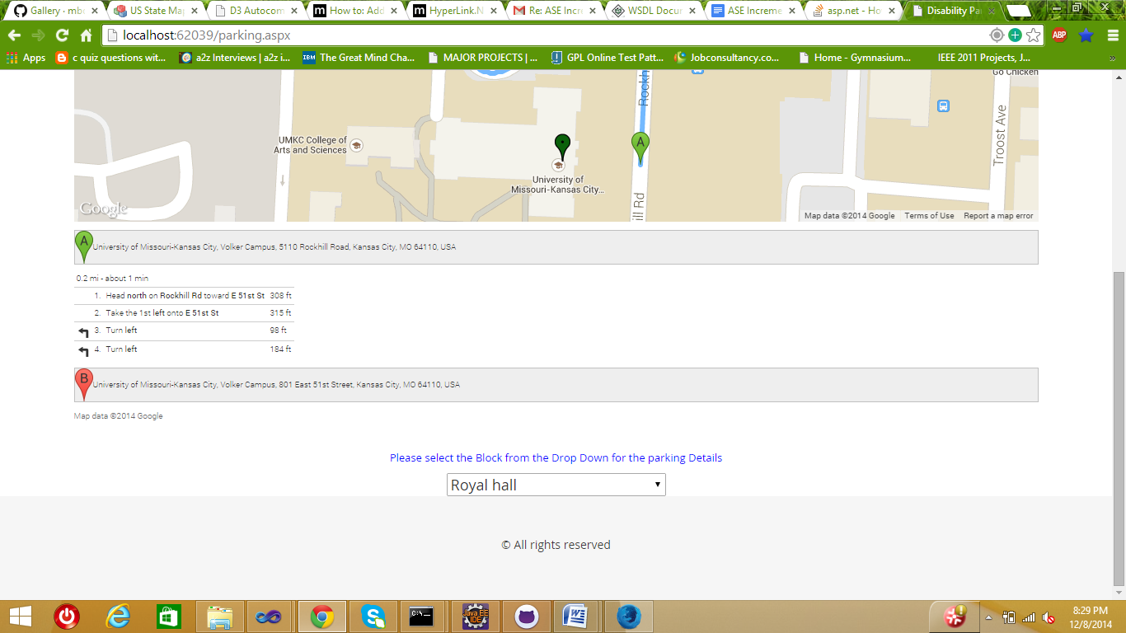

Places

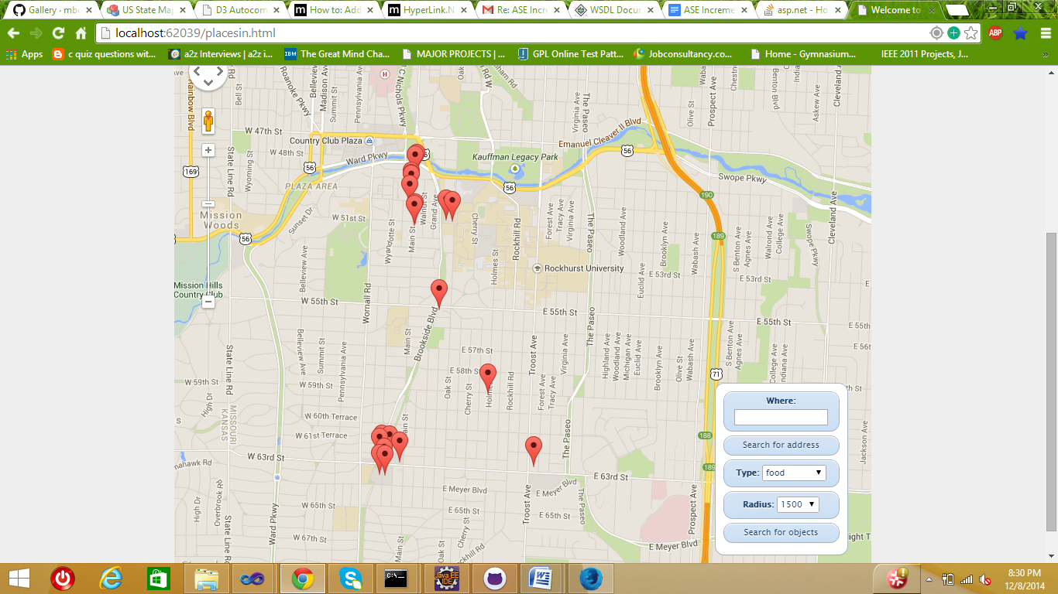

Admin Home

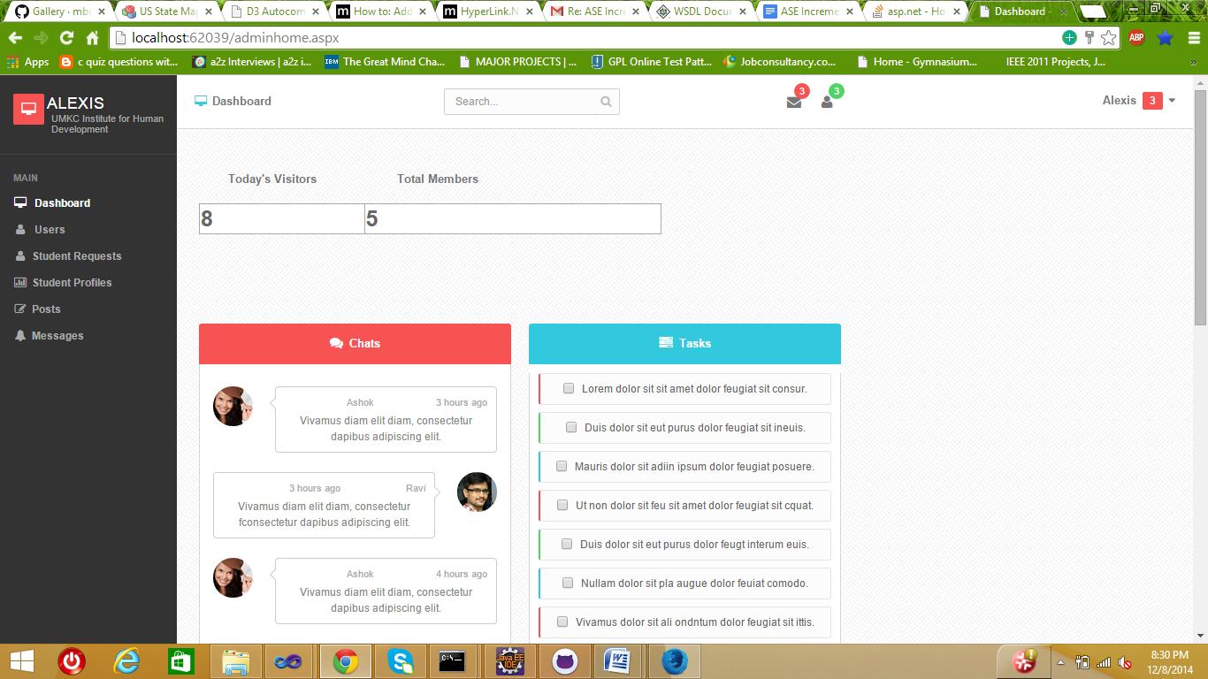

Users /Staff

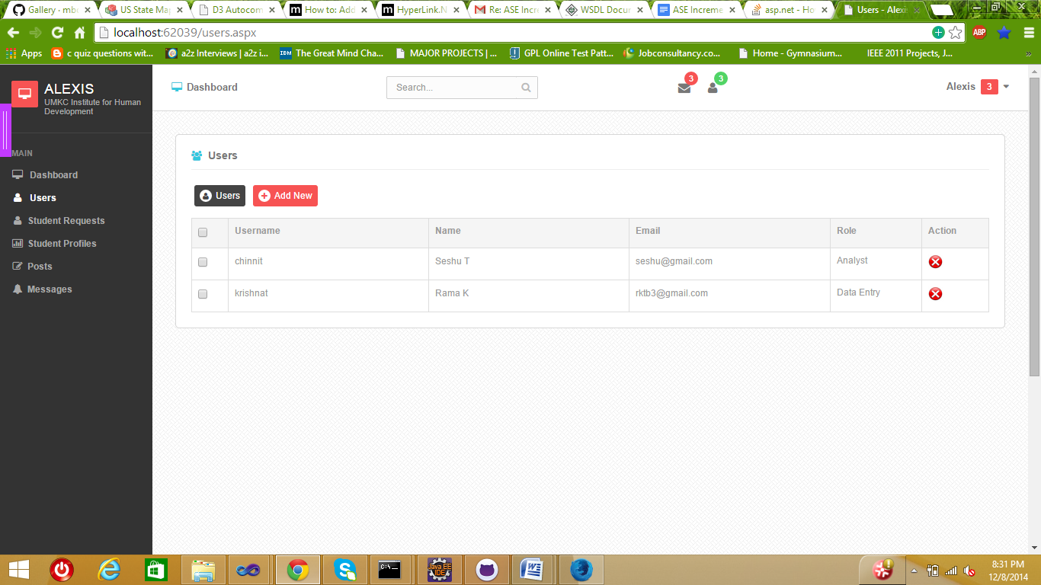

Adding new user

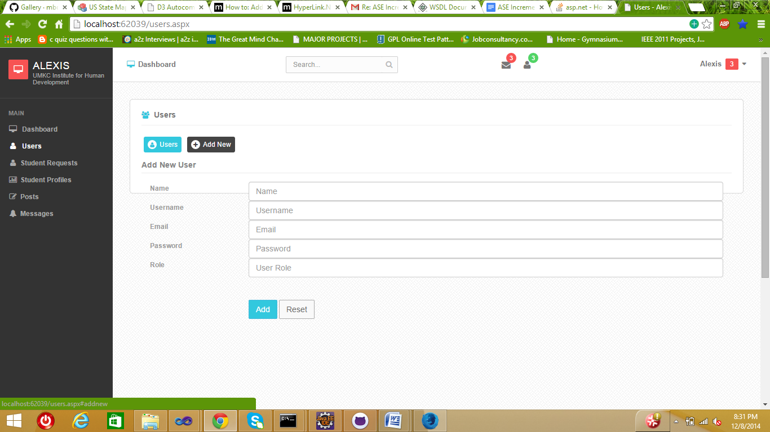

Student Request - Approve /Decline

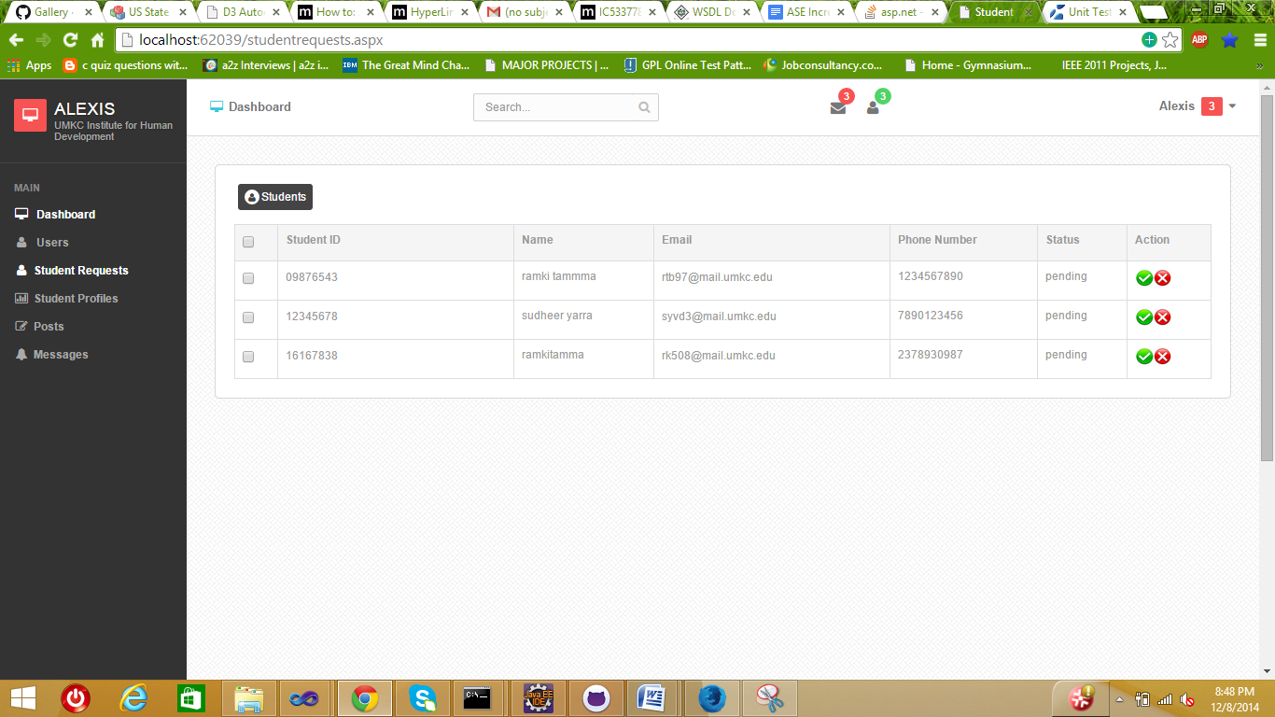

Green – Approve

Red – Decline

Student Profiles

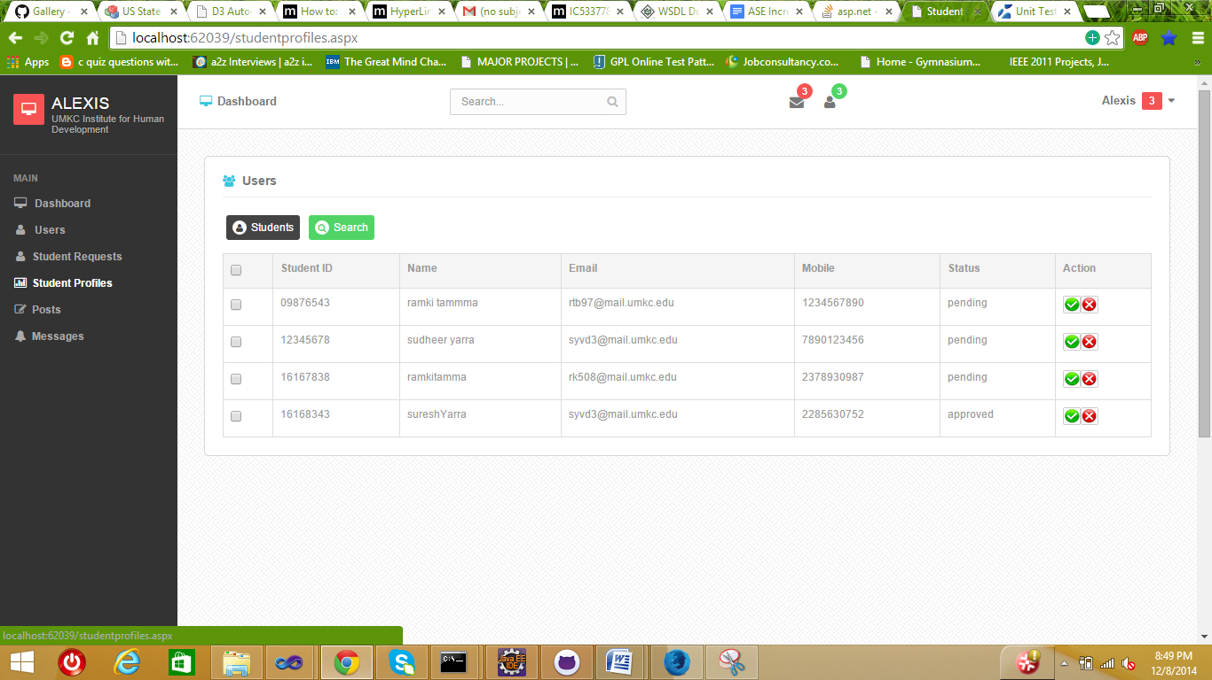

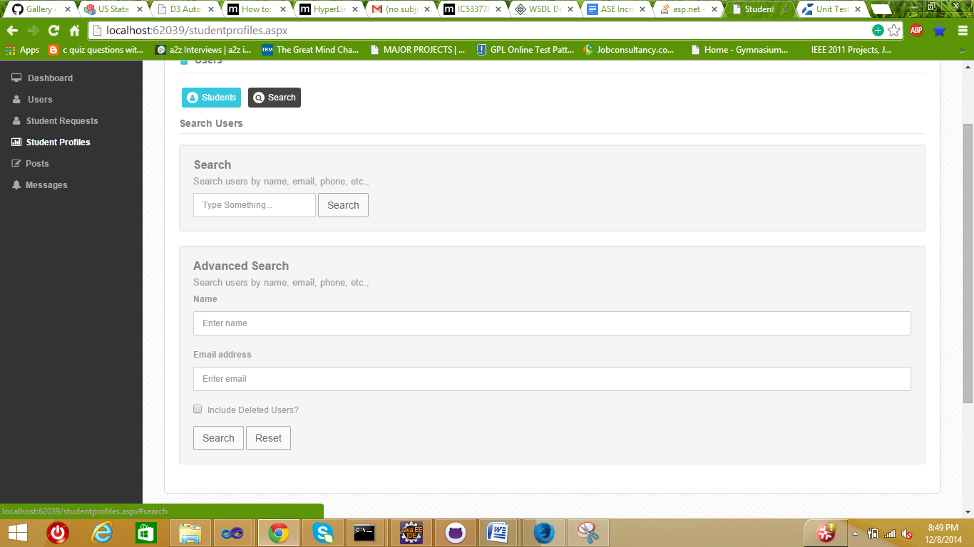

Admin posts

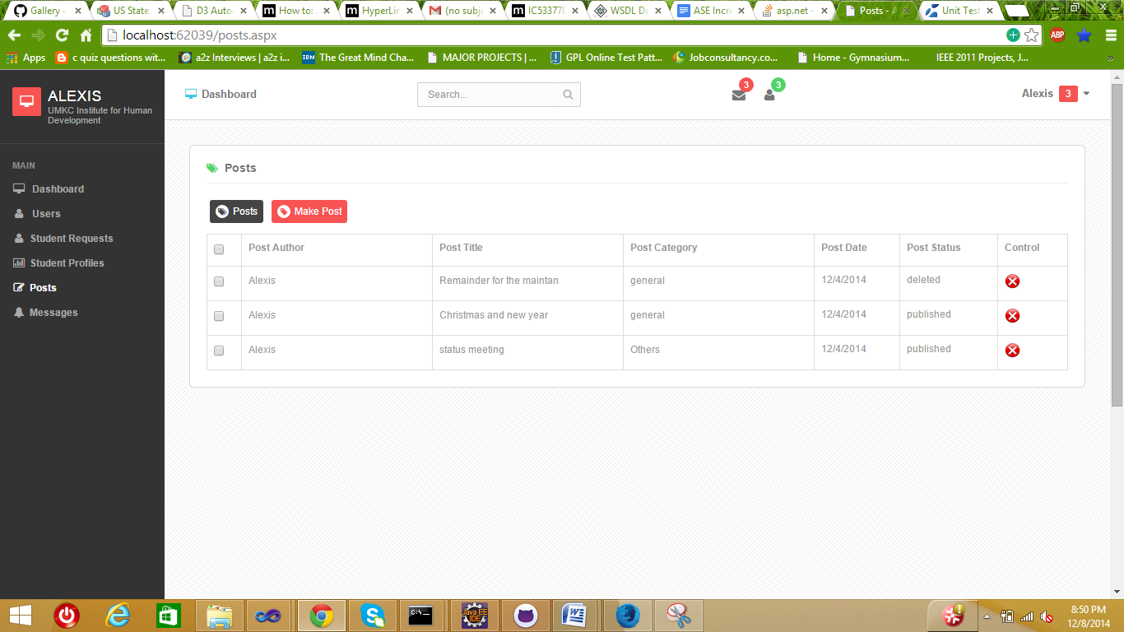

Making New post

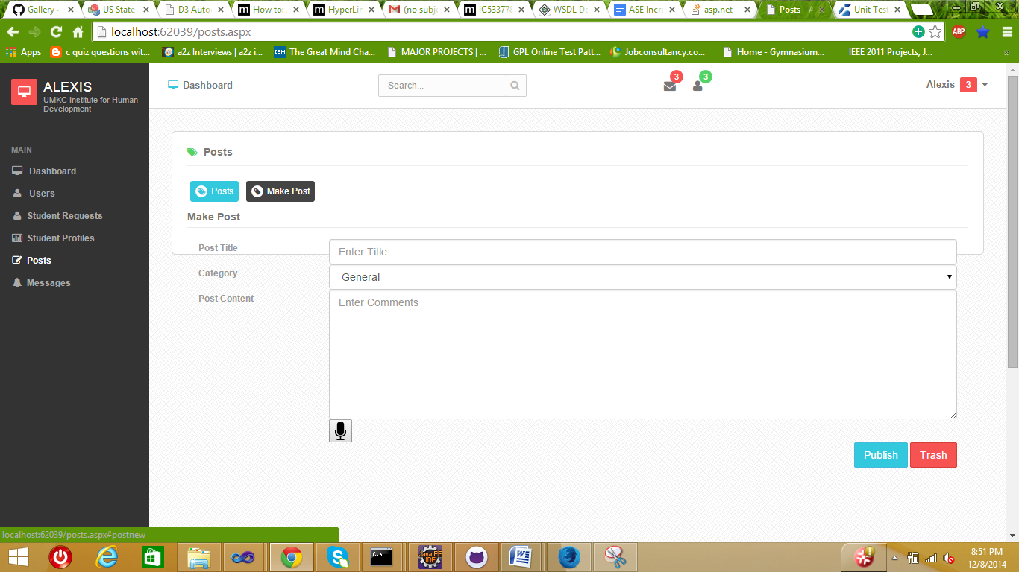

Student Goals Set

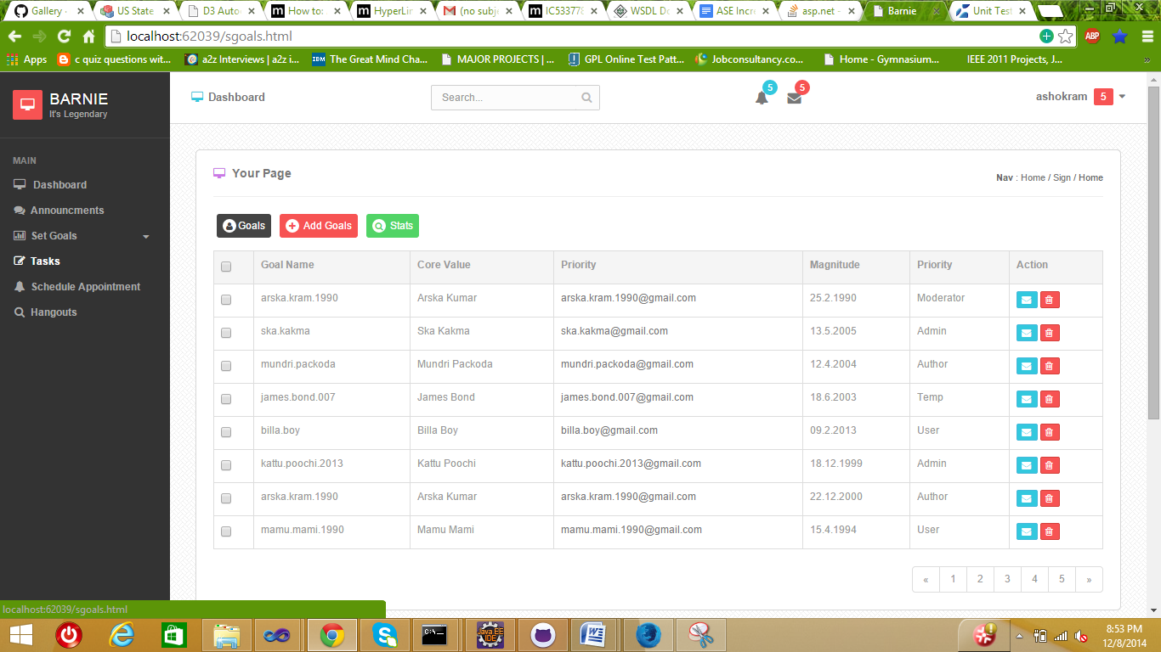

Adding a new Goal

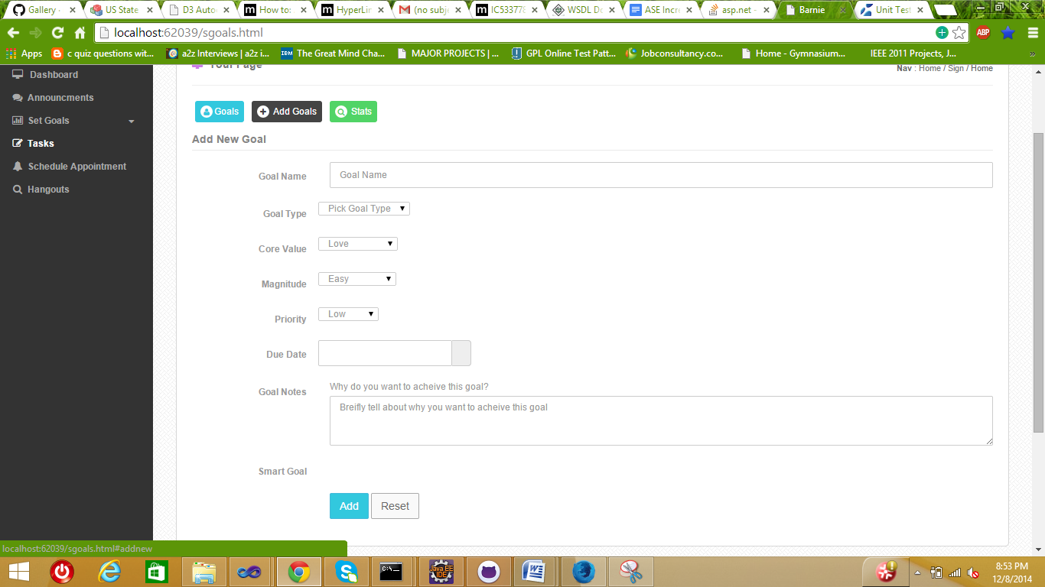

Goal Statistics’

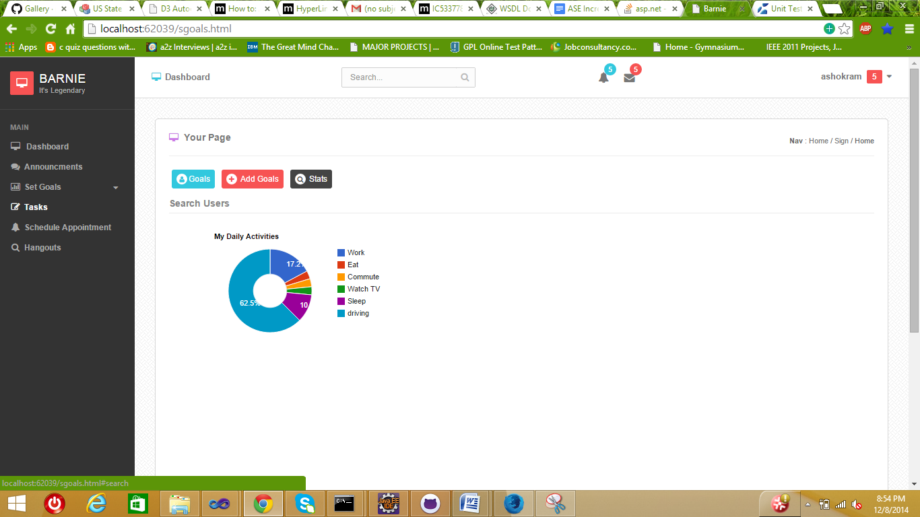

Appointment Booking

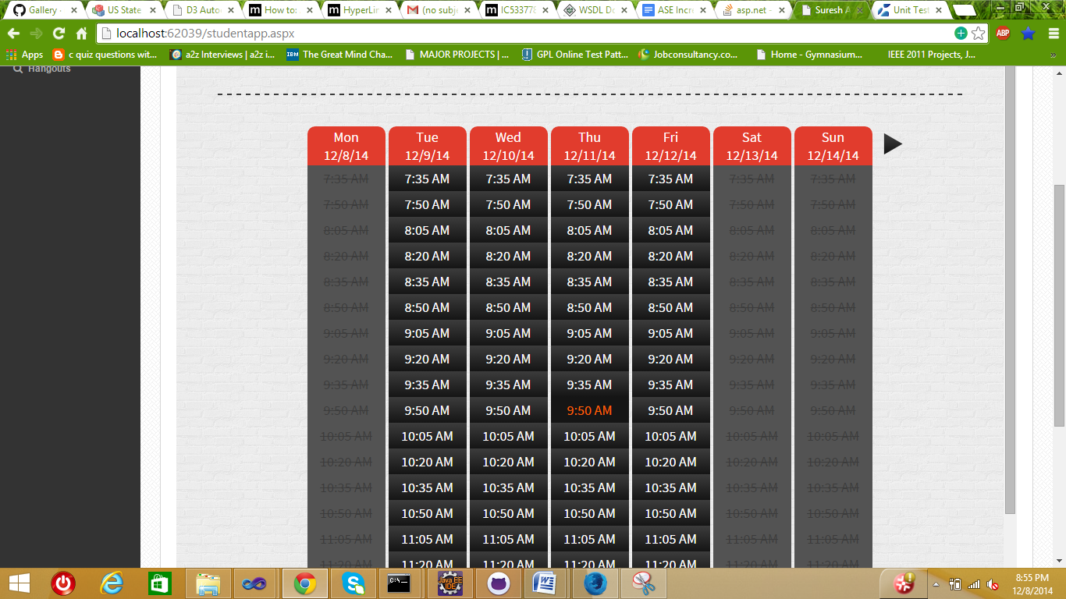

Conform Booking

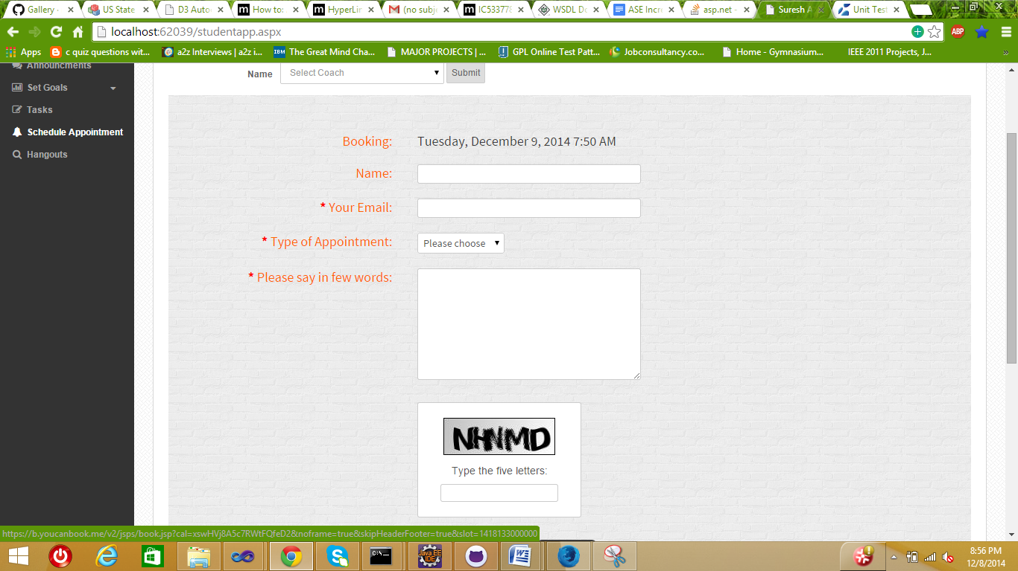

Admin Messages pop –up

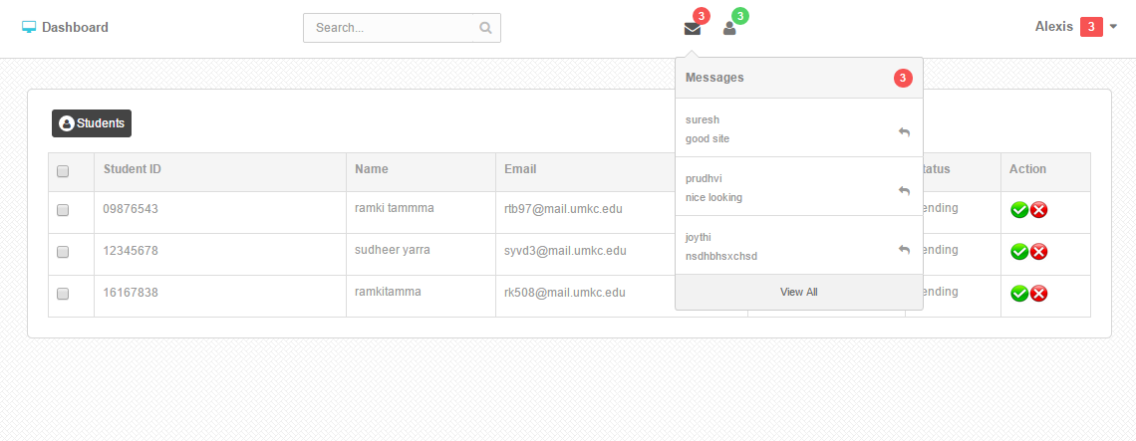

Message pop-up

